Window Commands Lane Dorscher
- Run the Performance Monitor on your computer and take a screen print of your % Processor time.
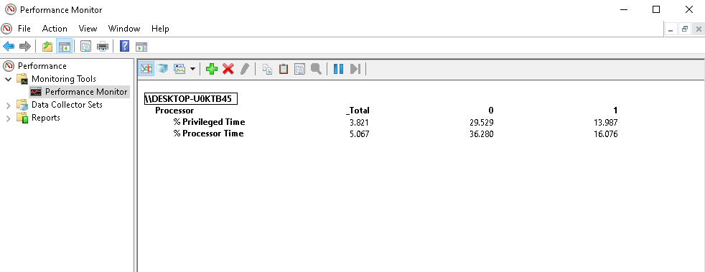
- Based on what you have learned, is this value high?
No, this value is not high. No heavy task is being performed on my computer and therefore this percentage is roughly where my computer might sit idle.
- Run Performance Monitor on your computer and take a screen print of your % Privileged time.
- Explain what the % Privileged time measures.
% Privileged Time measures how much of the CPU’s processing time is spent executing operating system kernel functions and device drivers. A high % privileged time could indicate issues with drivers or kernel related bottlenecks.
- Run Performance Monitor on your computer and take a screen print of your User time.
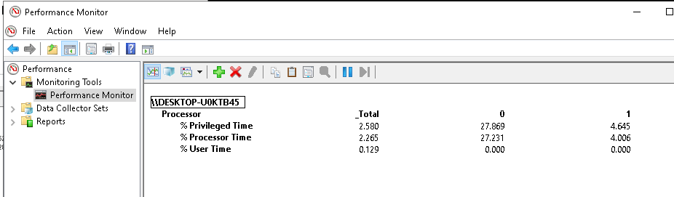
- Explain what the % User time measures.
This represents the CPU time spent running programs, services, and background apps.If this percentage is high, it usually means user applications are heavily using CPU resources

